CS 470 Module Five Assignment One Guide

Part One: Creating the Question Table

- Navigate to the DynamoDB console page. As in the previous modules, navigate to the console through the Services drop-down menu and select the service you want. In this case, select DynamoDB. You can find DynamoDB under the Database group, or you can type it in the search bar.

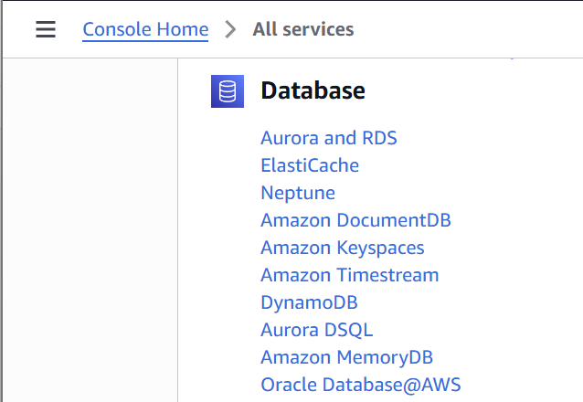

- Select the Create table button.

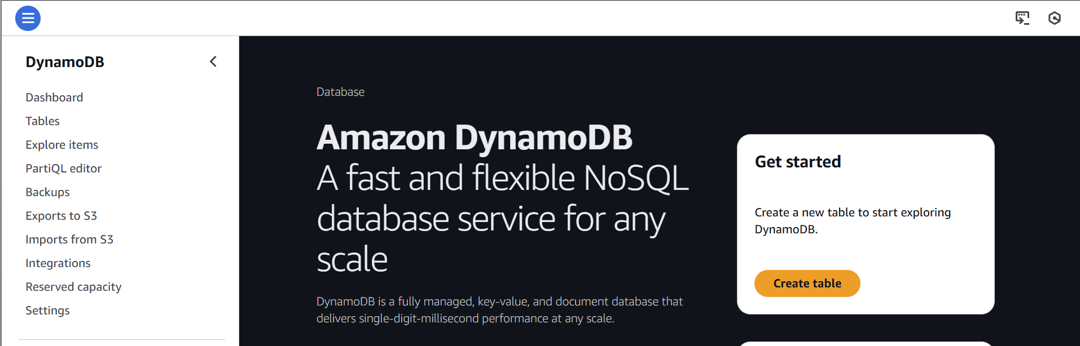

- Enter “Question” in the Table name field.
- Enter “id” in the Partition key field and set the type as “String.”
- Make certain that the Sort key box is empty.
- Leave all other Table settings at the default.
- Scroll down to the bottom of the page and click the Create table button in the lower-right corner.
- AWS will create the table. Creating the table may take a minute or two.

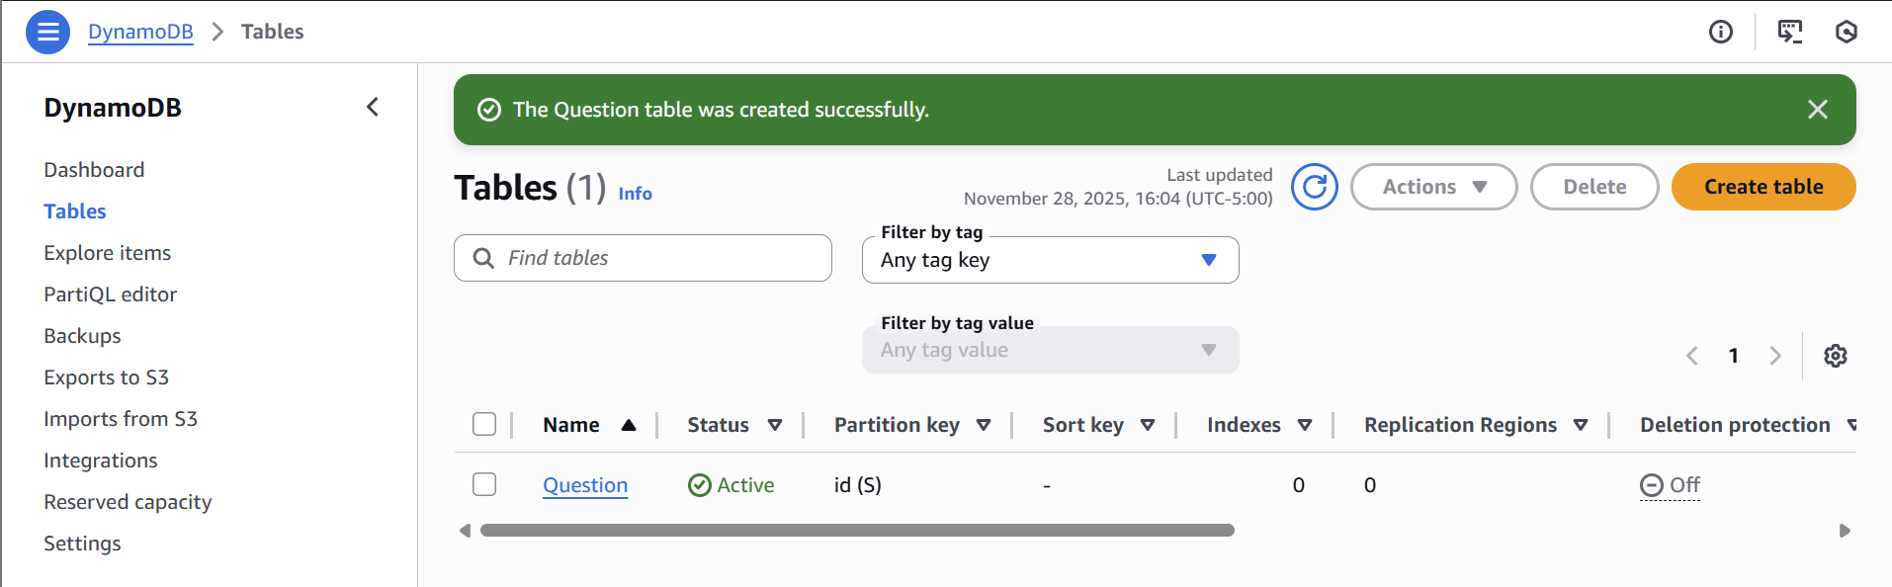

- When it is complete, click the Question table name to view the table settings.

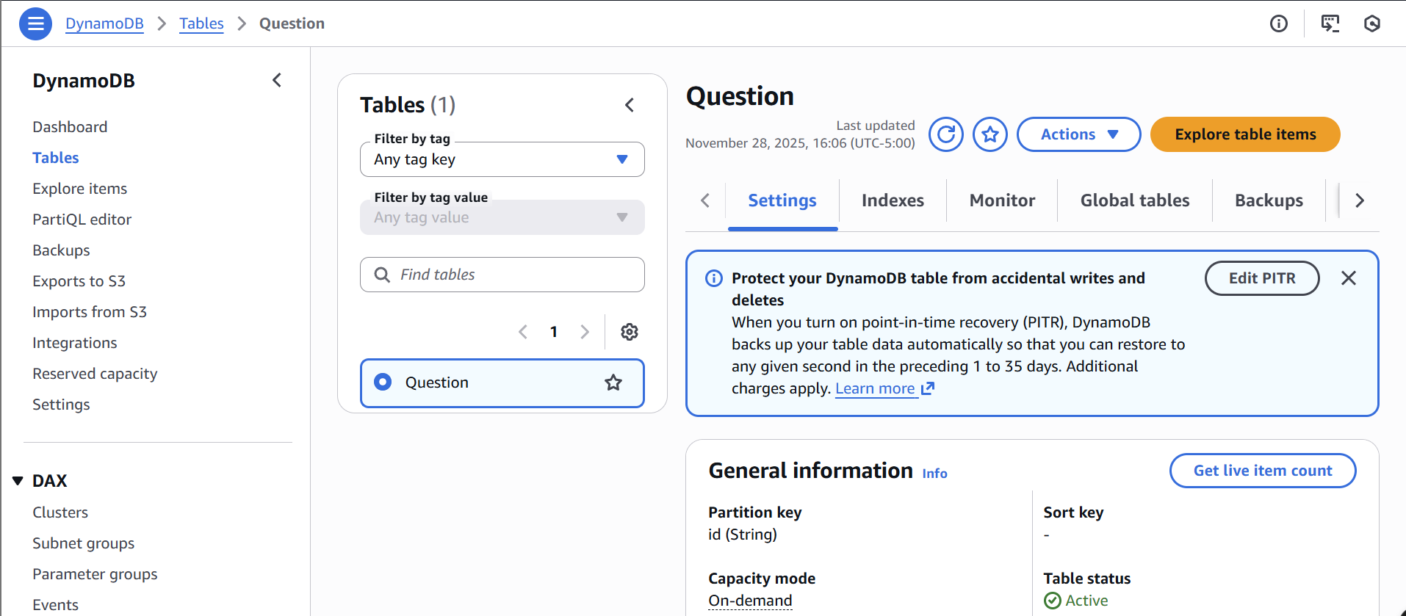

Congratulations! You have created your first DynamoDB table.

Before moving to Part Two, click the orange Explore table items button. The console will scan the table and show you all the records. You have none. This page will be helpful to you for the rest of this module and the subsequent modules. This page allows you to see the items in your database quickly.

Part Two: Adding Items and Attributes

- Since DynamoDB is technically schema-less, it creates a schema based on the items you insert. As such, you will not add attributes in the traditional way before you insert data. You will add attributes by inserting an item.
- Picking up from step 9 in Part One, click the orange Explore table items button.
- Click the Create item button at the bottom-right of the page.
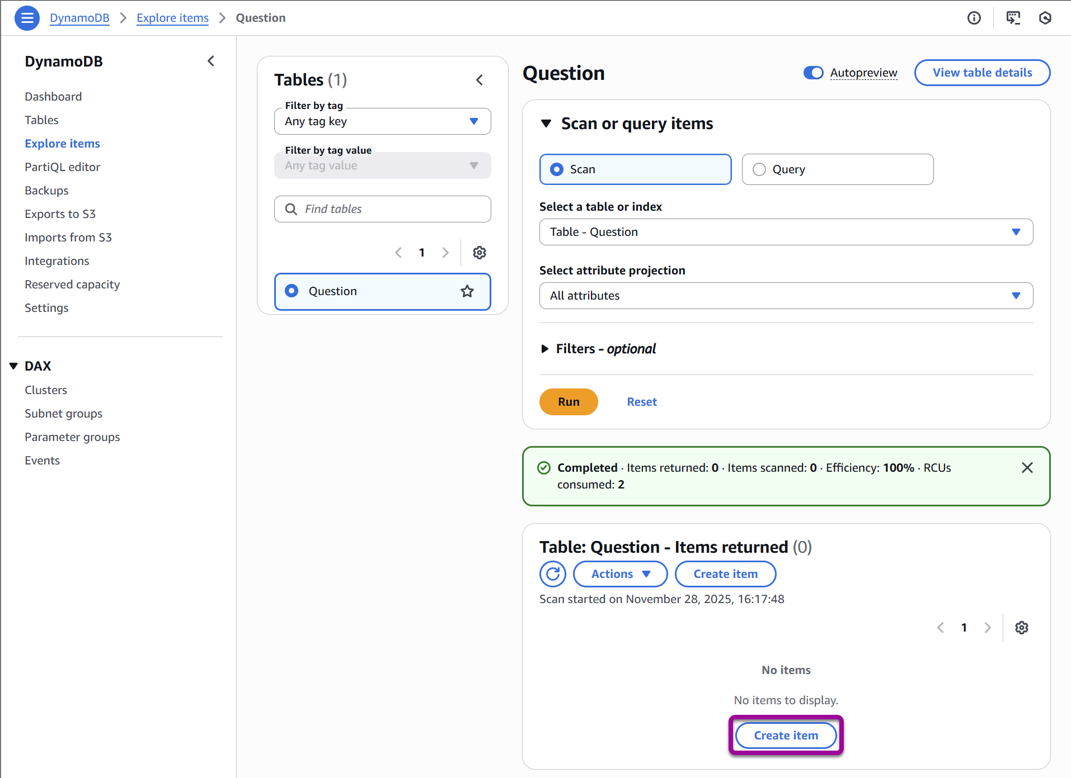

- The console will show the Create item screen. Here, you enter items directly.

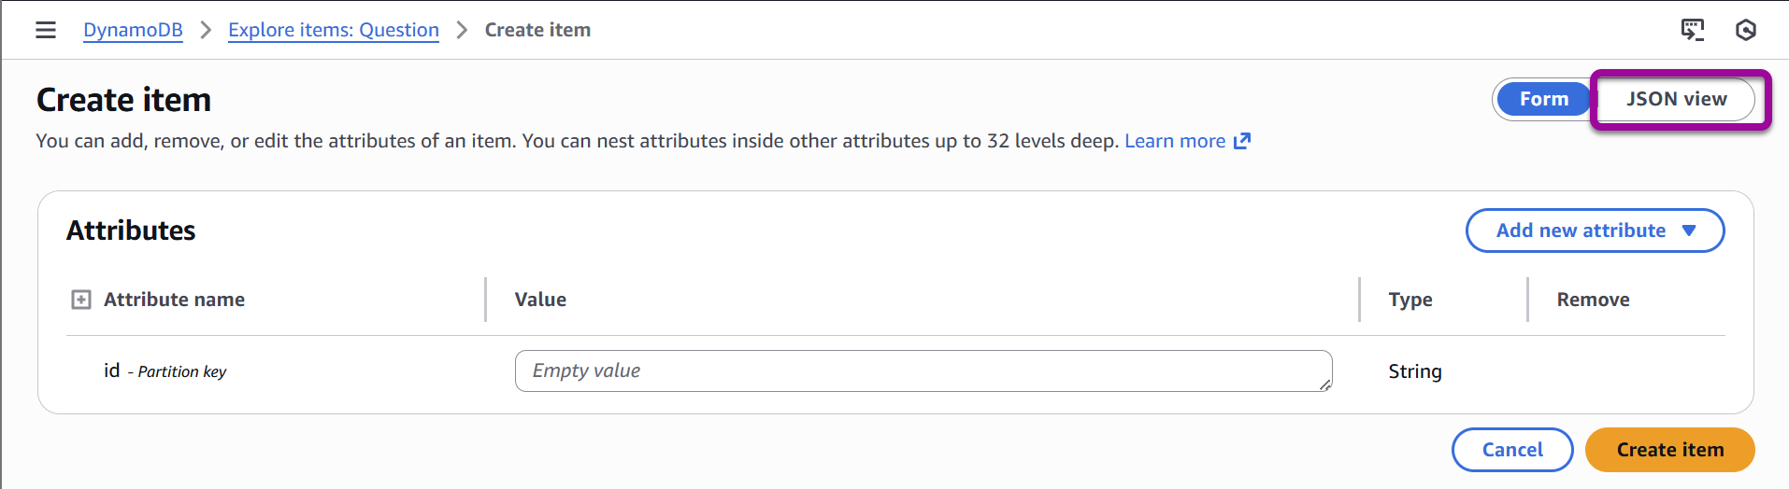

- Click the JSON view button in the top right. This view will allow you to enter items in JSON format instead of attribute by attribute in the tree view.
- Click to turn off the View DynamoDB JSON configuration.
- Paste the JSON below into the window, overwriting the existing text. A new GUID has been generated as the id to ensure uniqueness.

{
"id": "5eb59b7f80433e00045a7dfb",
"categorySlug": "angular",
"questionSlug": "what-is-angular",
"question": "What is Angular",
"negativeVotes": 0,
"positiveVotes": 0,
"answers": []
}

Note: If you receive a format error, make certain that View DynamoDB JSON is turned off at the top. It will be greyed out once you have already pasted in the block, hit Ctrl-Z and then you can turn it off and paste in again.

- Click the Create Item button in the lower-right corner.
- You should now be able to see the item in the Items Returned section at the bottom of the page.

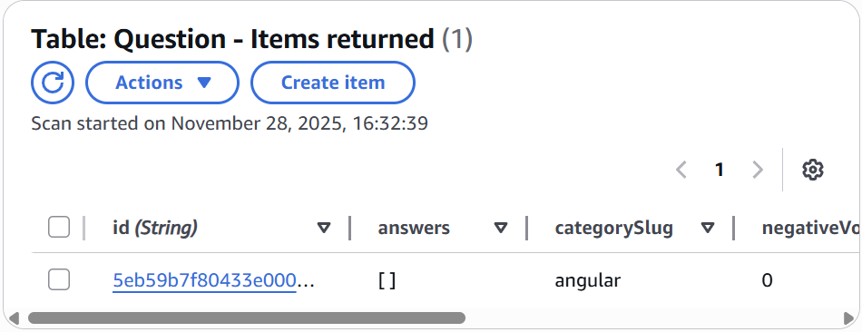

- As you can see, DynamoDB created the other attributes and populated the item.
- Select the id link in the id field. Selecting the link will bring up the Edit item screen.

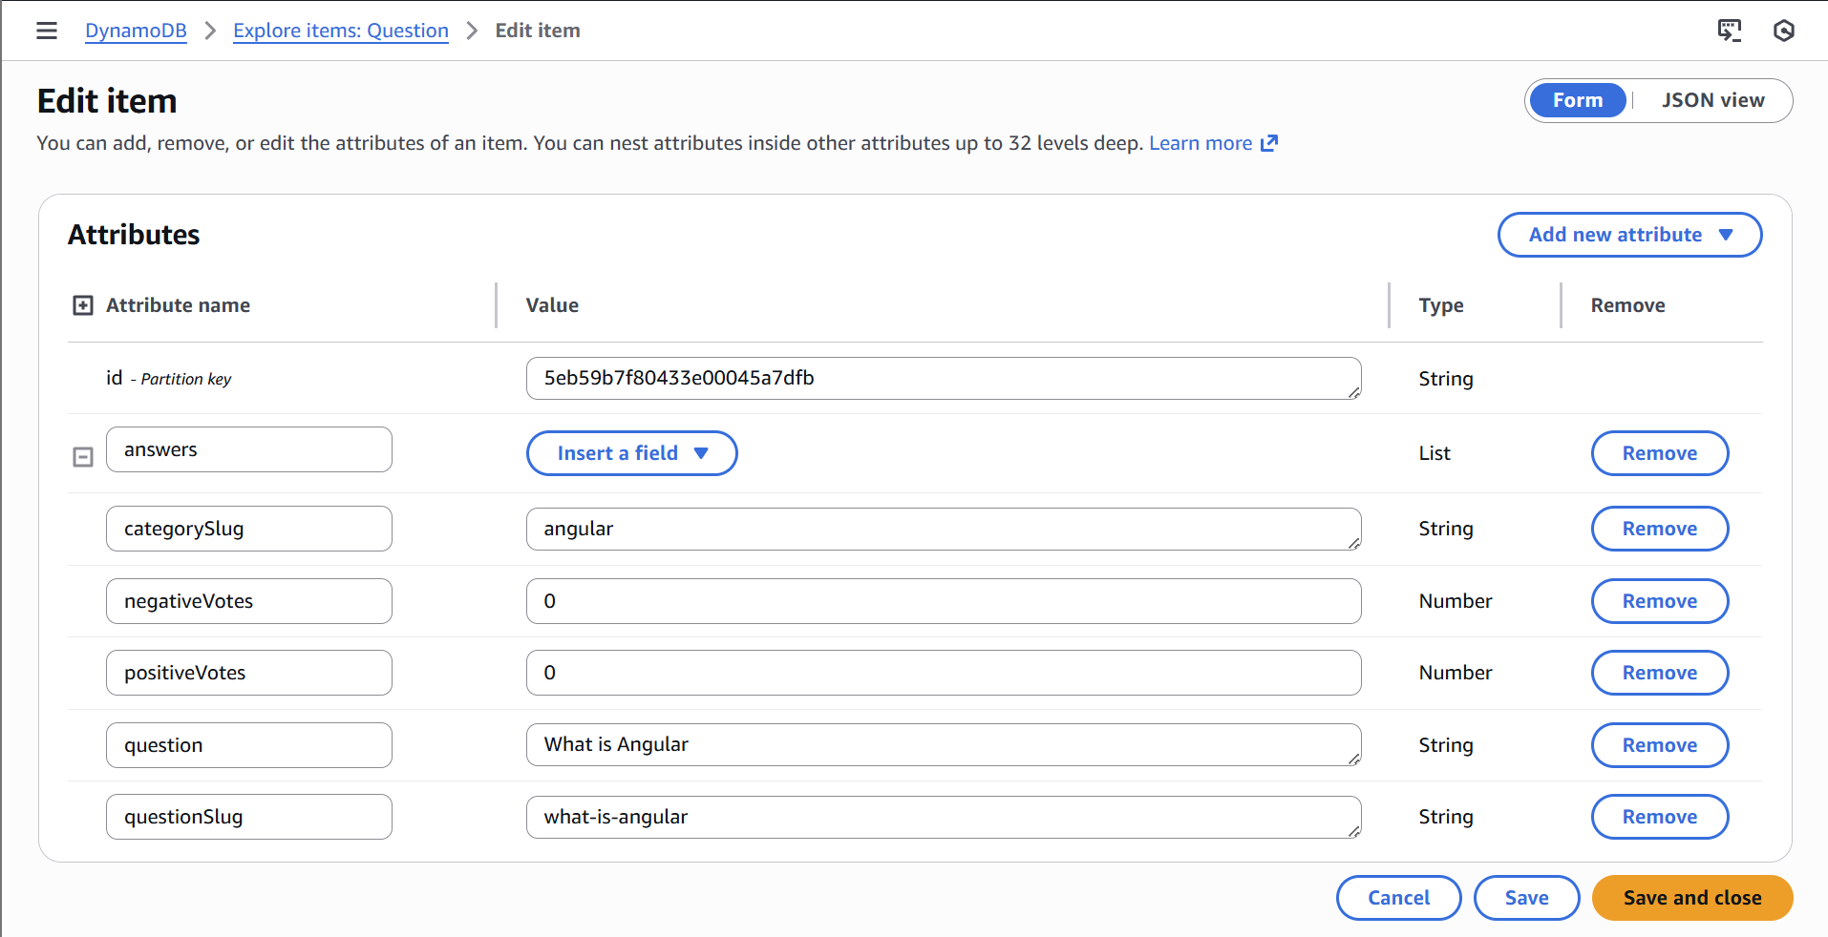

- From this screen, you can update your record if necessary. Click Cancel to exit the editing view.
- There is one last thing to know about this screen. Select the Actions drop-down menu next to the Create item button while your item is selected. This menu allows you to duplicate, edit, or delete an item or export the table to a CSV file. If you duplicate the item, you must provide a new id value. If you delete the item, you will be asked to confirm before deleting it. Download results to CSV allows you to export your database.

Note: the menu options will be greyed out if you did not first select the record with the checkbox to the left.

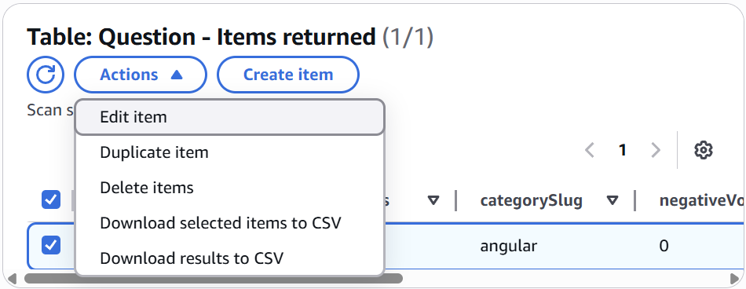

- Modify the JSON above to create four more Question entries. Make certain each id is unique.

Congratulations! You have created and populated your Question table. You will create the Answer table in Part Three. You could have designed Answer as an array of answer items inside your Question table, but the Angular application expects Answer to act as an independent table.

Part Three: Creating the Answer Table

- Using the steps for the Question table, click Tables from the left menu.
- Create a new table called “Answer” with an id partition key and string type.
- Click to view the Explore table items.
- Click the Create item button at the bottom-right of the page.
- Click the JSON view button in the top right. This view will allow you to enter items in JSON format instead of attribute by attribute in the tree view.
- Click to turn off the View DynamoDB JSON configuration.
- Paste the JSON below into the window, overwriting the existing text. The questionId should match the id used for an item in your Question table.

{
"answer": "Because it is the backbone of angular",
"negativeVotes": 0,
"positiveVotes": 0,
"id": "5b8629d2af53c20004793ac0",
"questionId": "5eb59b7f80433e00045a7dfb"
}

That’s it! You now have your tables and can work with your data through the AWS console.

